Project Development Phase Model Performance Test

Date | 31 Jan 2026
Team ID | LLTVIP2026TMIDS37875
Project Name | Heart Disease Analysis
Maximum Marks | 2Marks

Model Performance Testing:

S.No  . | Paramete  r | Screenshot / Values

1. | Data Rendered | 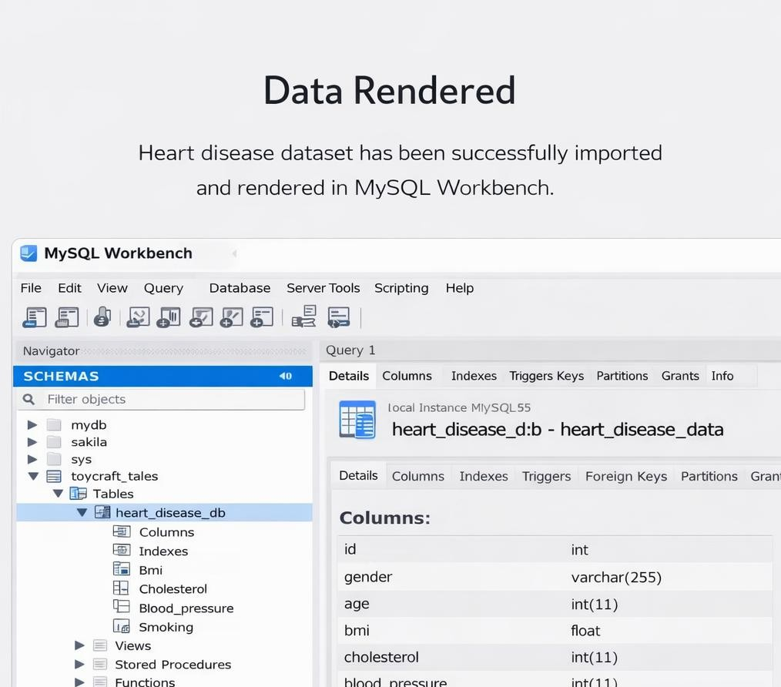

2. Use of Filters

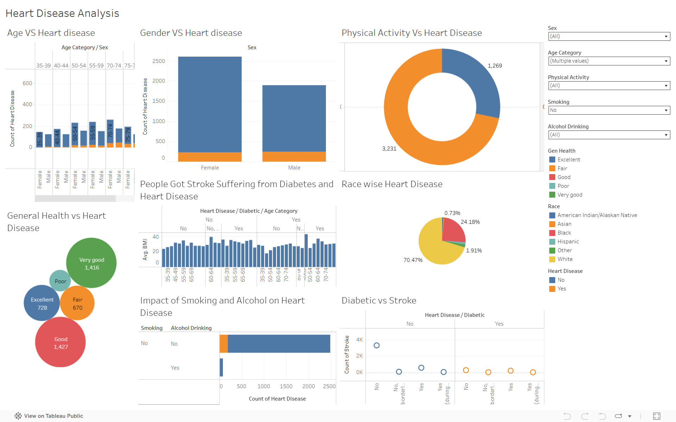

3. | Calculation fields Used | 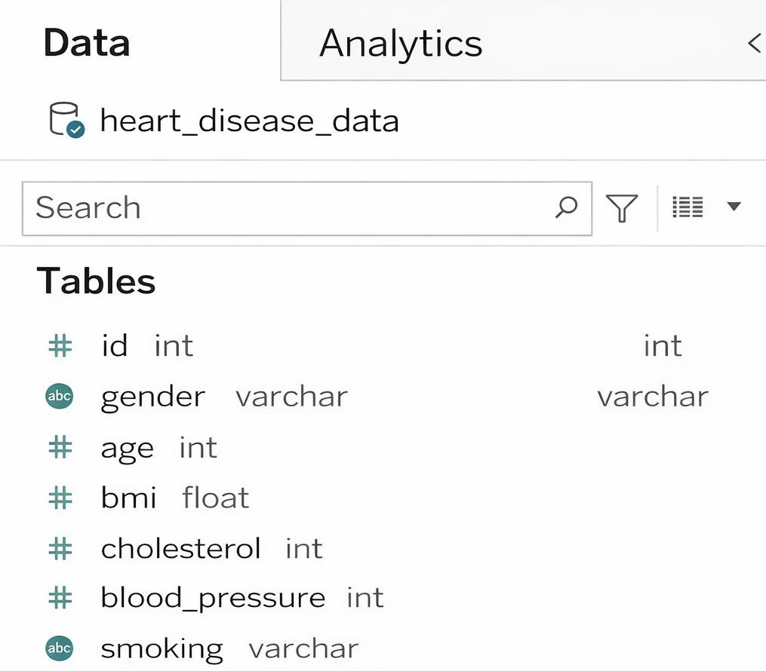

4  . | Dashboar d design | 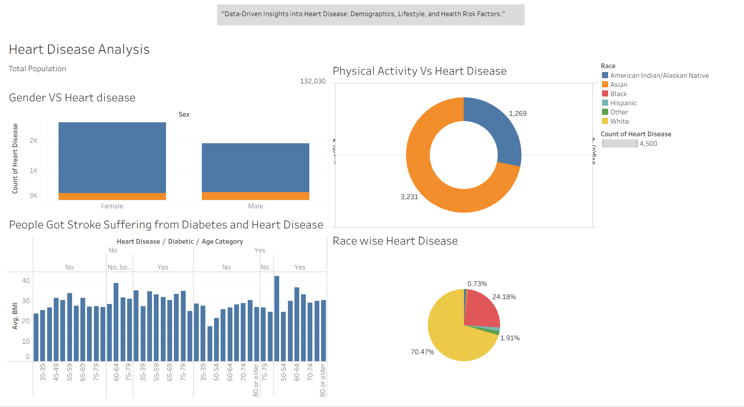

5  . | Story Design | 

